Date: 22.01.2021
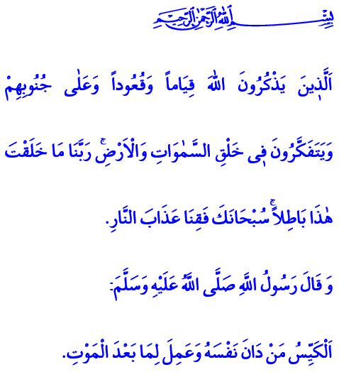
HOW MIND WORSHIPS: TAFAKKUR (CONTEMPLATION)
Honorable Muslims!
In the verse I have recited, Allah the Almighty (swt) states as follows, “They always remember Allah while standing or sitting or [lying] on their sides. They give thought to the creation of the heavens and the earth, saying, ‘Our Lord! You did not create this aimlessly; exalted are You above such a thing! Protect us from the punishment of the Fire!’”
Dear Believers!
One of the greatest blessings the Almighty Allah (swt) has bestowed upon us humans is mind and reason. It is a superior faculty we are blessed with that helps us distinguish true from false, right from wrong, and useful from harmful. It is through this faculty that human is able to comprehend the verses/signs of Allah and make their lives more meaningful. They avoid the evil and turn to the good. They attain
great rewards in the Hereafter if they use their reason in the way of the good. They end up in misery, however, if they use their mind in the way of the evil.
Dear Muslims!
The fruit of mind and reason is tafakkur. Tafakkur is the informed and purposeful thinking in order to make sense of the reality and act appropriately. Through tafakkur we comprehend our reason for existence, the importance of servitude to Allah (swt), the value of time, and the merit of good deeds. We notice the unqiue balance of the universe and countless blessings. We figure out the wisdom in the creation of the heavens and earth, mountains and seas, the Moon and the Sun, and the countless known and unknown beauties. Through tafakkur we adopt a reflective perspective to look into events, draw lessons from them, and assume our part of the responsibility.
Dear Believers!
The Prophet Muhammad (saw) states as follows, “The clever person is the one who subjugates his soul, and works for what is after death.”
Happy be they, who use their mind in the way of becoming virtous people and truthful servants of Allah (swt), and earning His appreciation! Happy be they, who view this world as a farm for cultivating the Hereafter and prepare from today for the eternal life.

Al-i ‘Imran, 3/191.
Tirmidhi, Sifat al-Qiyamah, 25. General Directorate of Religious Services

